Lab experiment
4.Implementation of java program using multithreading

Aim:
To write a Java program to implement multithreading by creating and executing multiple threads simultaneously.

Algorithm:
1.Start the program.
2.Create a class that extends the Thread class.
3.Override the run() method to define the task performed by each thread.
4.Create two thread objects.
5.Start both threads using the start() method.
6.Each thread executes its task concurrently and displays its thread name and count.
7.Wait for both threads to complete execution using join().
8.Stop the program.

Coding:

class MyThread extends Thread { public void run() {
for (int i = 1; i <= 5; i++) {
System.out.println(getName() + ":" + i);

try {
Thread.sleep(100);
} catch (InterruptedException e) {
System.out.println(e);
}
}
}
}

public class Multithreading { public static void main(String[] args) throws InterruptedException {

MyThread t1 = new MyThread();
MyThread t2 = new MyThread();
t1.start(); t2.start(); t1.join(); t2.join();
}
}

Output:

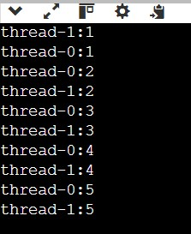

Result:
Thus, a Java program implementing multithreading was executed successfully by creating and running two threads concurrently.

